

Rodriguez Irampa

Rachel Nderitu - 666062

Sharon Justine Nalubiri - 666248

Eddy Waweru -665939

Jua Kali Artisans oracle command code.

***CREATE TABLE supplier (***

***SUP_ID(10) PRIMARY KEY,***

***SUP_LNAME VARCHAR2(50),***

***SUP_FNAME VARCHAR2(50),***

***SUP_CONTACT VARCHAR2(50),***

***SUP_LOCATI VARCHAR2(50),***

***SUP_DATE DATE,***

***RM_ID NUMBER(10));***

***CREATE TABLE material (***

***RM_ID NUMBER(10) PRIMARY KEY,***

***RM_NAME VARCHAR2(50),***

***RM_QUANTITY NUMBER(10),***

***RM_PRICE NUMBER(10,2),***

***RM_IN_DATE DATE,***

***PROD_ID NUMBER(10));***

***CREATE TABLE product (***

***PROD_ID NUMBER(10) PRIMARY KEY,***

***PROD_DESCRIPT VARCHAR2(50),***

***PROD_QUANT NUMBER(10),***

***PROD_PRICE NUMBER(10,2),***

***PROD_DISCOUNT NUMBER(10,2),***

***ORD_ID NUMBER(10));***

***CREATE TABLE orders (***

***ORD_ID NUMBER(10) PRIMARY KEY,***

***ORD_DATE DATE,***

***ORD_QUANTITY NUMBER(10),***

***PAYMENT_M VARCHAR2(50),***

***CUS_ID NUMBER(10));***

***CREATE TABLE customer (***

***CUS_ID NUMBER(10) PRIMARY KEY,***

***CUS_LNAME VARCHAR2(50),***

***CUS_FNAME VARCHAR2(50),***

***CUS_PHONE VARCHAR2(20),***

***CUS_ADDRESS VARCHAR2(100),***

***ORD_ID NUMBER(10));***

In our mind we were thinking of a systematic flow of instructions, thus the creation and development of this database.

# The schemas

## External Schema



This external schema represents what the customer (the seller and buyer) will see. The buyer will only be able to see their side if the seller decides to have an online database

## 2.0 Conceptual Schema



This schema represents how each entity will be linked to the other (a flow of instructions which will lead to a desired result).

## Internal Schema



# 2. The database

## 1. The supplier table

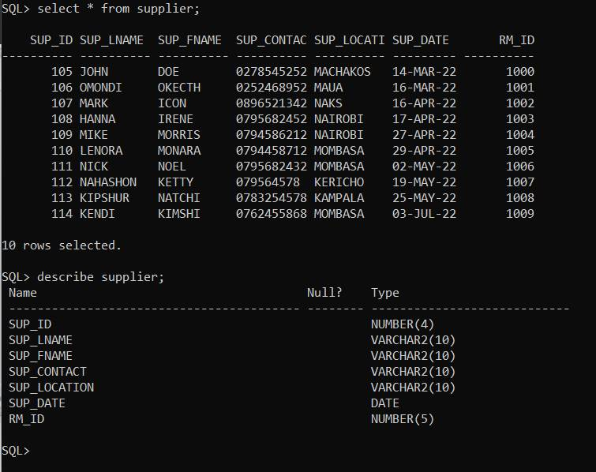

## 2. The Raw Material Table

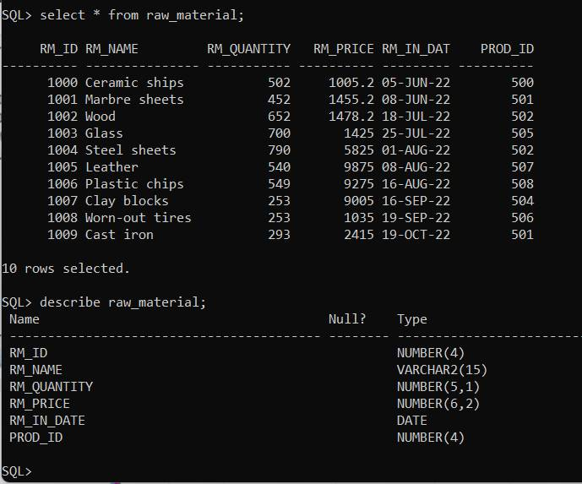

## The product Table

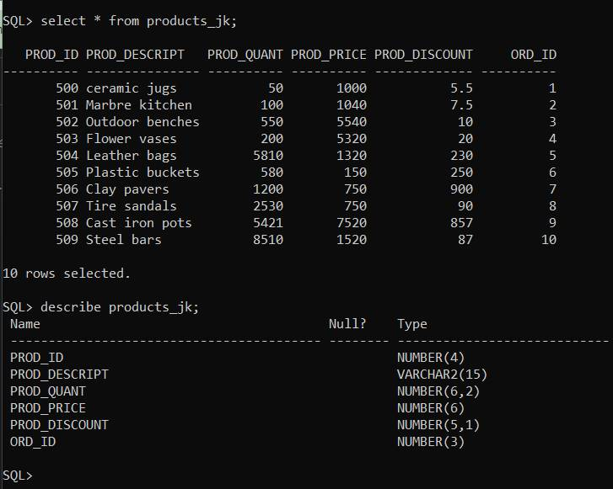

## The Order Table.

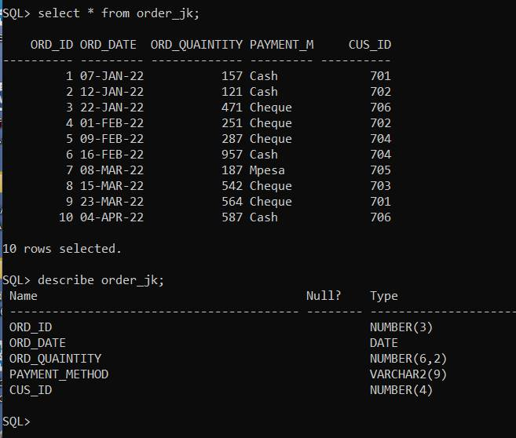

## The Customer table

